Lecture IX
General Anaesthetics
General anaesthetics are a group of drugs that produce loss of consciousness ; and, therefore, loss of all sensation. The absolute loss of sensation is termed as anaesthesia (derived from the Greek word meaning insensitivity or lack of feeling). General anaesthetics bring about descending depression of the central nervous system ; starting with the cerebral cortex, the basal ganglia, the cerebellum and finally the spinal cord.
These drugs are used in surgical operations to induce unconsciousness ; and, therefore, abolish the sensation of pain. Horace Wells, a Hartford dentist first and foremost demonstrated the usage of nitrous oxide (‘laughing gas’) as an effective surgical anaesthetic in 1844. However, its application as a ‘general anaesthetic’ resurfaced in mid 1860’s when it was dispensed in steel cylinders as an admixture with oxygen. Interestingly, nitrous oxide finds its application even today, particularly in combination with other anaesthetic and analgesic agents. Later on, William Morton — a Boston dentist demonstrated the anaesthetic actions of diethyl ether in 1846 at the historical ‘‘Ether Dome’’ located at the Massachusetts General Hospital. In actual practice, the usage of diethyl ether followed by cyclopropane were withdrawn completely for being highly toxic amalgamated with equally dangerous physical properties, such as : flammable and explosive. The anaesthetic agents that have gained cognizance today are invariably hydrocarbons and ethers with halogen (F, Br, Cl) substitution.
Glassification
The general anaesthetics may be divided into three groups based solely on the method of administration. These are : inhalation anaesthetics ; intravenous anaesthetics ; and basal anaesthetics. The above three categories of general anaesthetics shall be discussed here with appropriate examples.
İnhalation Anaesthetics
Inhalation anaesthetics could be either volatile liquids or gases and they are administered through
inhalation process. As few typical examples are discussed below :
A. Ether USAN, Anaesthetic Ether BAN,
CH3CH2—O—CH2CH3
Ethane, 1, 1′-oxybis- ; Ethyl ether ; Diethyl ether ; Sulphuric ether ; U.S.P., B.P., Eur. P., Int. P.,

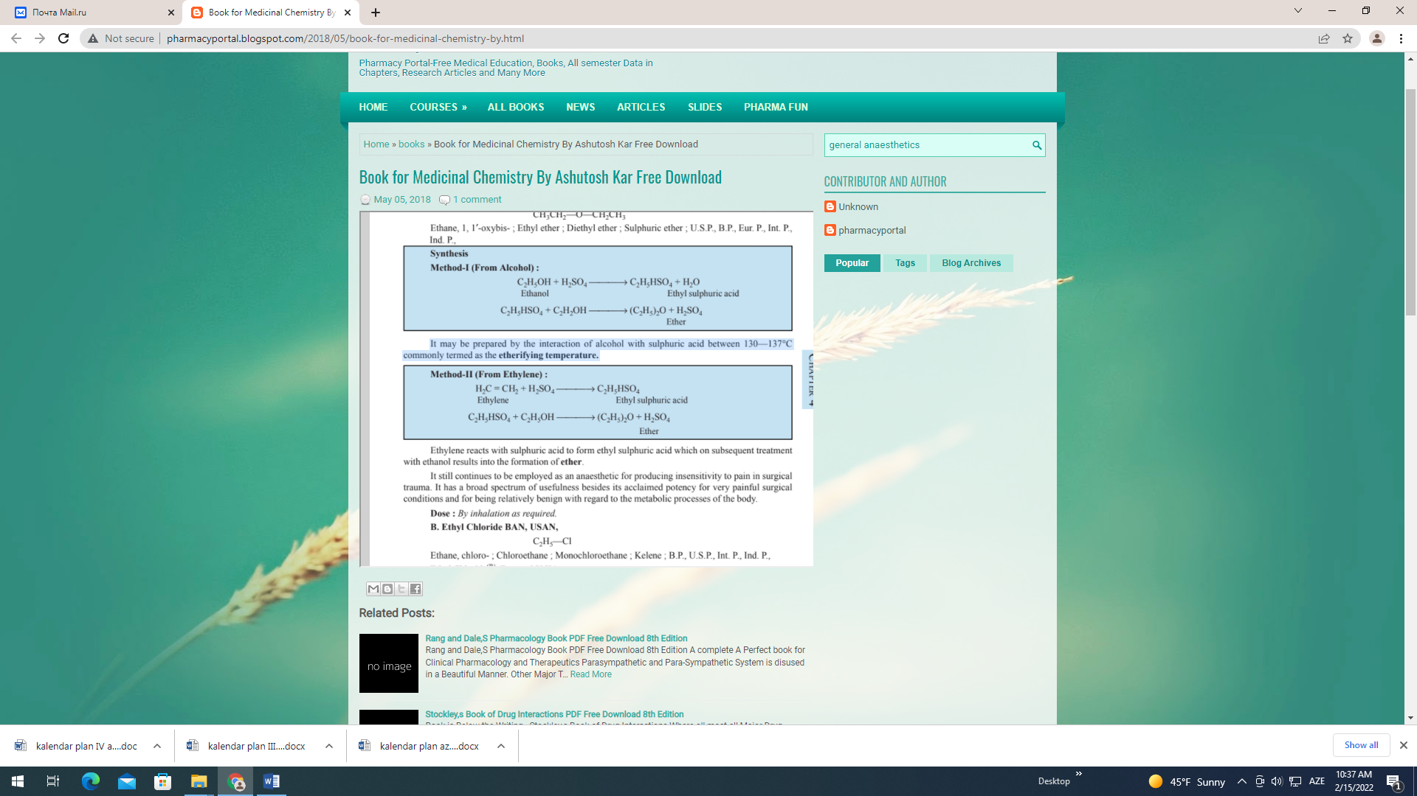
It may be prepared by the interaction of alcohol with sulphuric acid between 130—137°C commonly termed as the etherifying temperature.
Ethylene reacts with sulphuric acid to form ethyl sulphuric acid which on subsequent treatment with ethanol results into the formation of ether.
It still continues to be employed as an anaesthetic for producing insensitivity to pain in surgical trauma. It has a broad spectrum of usefulness besides its acclaimed potency for very painful surgical conditions and for being relatively benign with regard to the metabolic processes of the body.
Dose : By inhalation as required.
B. Ethyl Chloride BAN, USAN,
C₂H₅—Cl
Ethane, chloro- ; Chloroethane ; Monochloroethane ; Kelene ; B.P., U.S.P., Int. P., Ind. P., Ethyl Chloride(R) (Bengue’ U.K.) ;
Synthesis
C₂H₅OH + NaCl + H₂SO₄ → C₂H₅Cl + NaHSO₄ + H₂O
Ethanol Ethyl chloride
Ethyl chloride is prepared conveniently by distilling together a mixture of alcohol, sodium chloride and sulphuric acid.
Used in the past as a general anaesthetic by inhalation, particularly for minor operations, it is also employed as a local anaesthetic by ‘freezing’. It is no longer used as a general anaesthetic because of its damage to the liver and serious disturbances of the cardiac rhythm.
Dose : Topical, as spray on intact skin.
C. Vinyl Ether BAN, USAN,
CH₂ = CO – O – CH = CH₂
Ethene, 1, 1′-oxybis- ; Vinyl ether ; Divinyl oxide ; B.P., U.S.P., Int. P., Ind. P.,
Vinesthene(R) (May and Baker) ; Vinydan(R) (Byk Gulden) ;
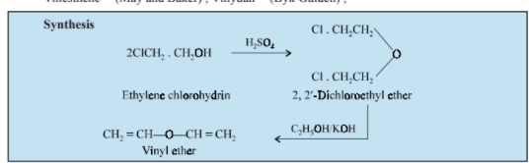

It is prepared by treating ethylene chlorohydrin with sulphuric acid to obtain 2, 2′-dichloroethyl ether, which on subsequent treatment with alkaline ethanol yields vinyl ether.
A volatile anaesthetic administered by inhalation, it is 4 times as potent as ether. Its prolonged inhalation for long operations is rather harmful because of the risk of liver necrosis.
Dose : By inhalation as required.
D. Cyclopropane INN, BAN, USAN,

Trimethylene ; B.P., U.S.P., Ind. P.,
Cyclopropane(R) (CI Pharmaceuticals U.K.)
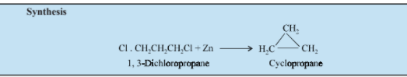
It may be prepared by the action of zinc metal (or sodium or magnesium) on 1, 3-dichloropropane. Cyclopropane is one of the most potent anaesthetics administered by inhalation with the help of a brass regulator. The chief merits of this anaesthetics over others are due to its non-irritant nature and rapid recovery from anaesthesia. Its demerits include : depressant effects on respiration, tendency to induce cardiac arrhythmias and to enhance haemorrhage.
Dose : By inhalation as required.
E : Fluroxene INN, USAN,
CF₃CH₂ — O — CH = CH₂
2, 2, 2-Trifluoroethyl vinyl ether ; Ethene, (2, 2, 2-trifluoroethoxy)- ; N.F. XIV ; Fluoromar(R) (Anaquest) ;

2, 2, 2-Trifluoroethanol undergoes addition to acetylene in the presence of basic catalyst under moderate pressure to yield fluroxene. It is a comparatively highly volatile pleasant-smelling anaesthetic employed most frequently for procedures requiring either the first or upper second plane of anaesthesia, e.g., cardiac, dental, obstetric, orthopedic and certain types of urologic and gynaecologic surgery. Being a good analgesic it brings recovery rapidly. Postoperative nausea and vomiting are uncommon.
Dose : By inhalation as required.
F. Halothane INN, BAN, USAN,
2-Brome-2-chloro-1, 1, 1-trifluoroethane ; Ethane, 2-bromo-2-chloro-1, 1, 1-trifluoro-; B.P., U.S.P., Eur. P., Fluothane(R) (Ayerst) ; Halothane(R) (May and Baker);
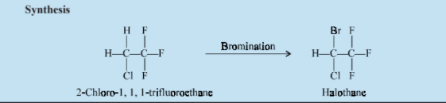
Bromination of 2-chloro-1, 1, 1-trifluoroethane yields halothane which is isolated from the reac-tion product by fractional distillation.
It is a relatively safe potent volatile anaesthetic administered by inhalation. It is twice as potent as chloroform and 4 times that of ether. It may produce any depth of anaesthesia without causing hypoxia. Being a non-irritant, its inherent hypotensive effect retards capillary bleeding and renders a comparatively bloodless field.
Dose : By inhalation as required.
G. Methoxyflurane INN, BAN, USAN,
CHCl₂CF₂—O—CH₃
2, 2-Dichloro-1, 1-difluoroethyl methyl ether ; Ethane, 2, 2-dichloro-1, 1, 1-difluoro-1-methoxy-; B.P., B.P.C., U.S.P., N.F. ;
Penthrane(R) (Abbott) ;
It is one of the most potent anaesthetic agents frequently used in practice today. In fact, it is employed to cause comparatively light anaesthesia with deep analgesic and muscle relaxation, features which make it convenient for short surgical operations, e.g., obstetrics.
Dose : By inhalation as required.
H. Trichloroethylene INN, BAN,

Ethene, trichloro-; B.P., U.S.P. 1970 ; Eur. P., N.F. XIV, Int. P., Ind. P.,
Trilene(R) (Ayerst) ; Trimar(R) (Ohio Medical)

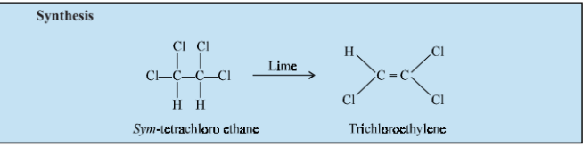
It may be prepared by the careful abstraction of the elements of hydrogen chloride from sym-trichloroethane with the aid of lime. It may be used sporadically as a weak volatile anaesthetic administered by inhalation. It pos- sesses an excellent analgesic property but is wanting miserably as a muscle relaxant. It is frequently employed in short surgical operations where a mild anaesthesia having a potent analgesia is desired, as in obstetrics.
Dose : By inhalation as required.
I. Nitrous Oxide BAN, USAN,
N₂O
Nitrogen oxide ; Dinitrogen monoxide ; Laughing gas ; B.P., U.S.P., Eur. P. Int. P., Ind. P., Entomox(R) (BOC Medishield U.K.) (N2O : O2 : : 1 : 1)
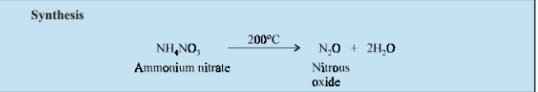
It may be prepared by heating ammonium nitrate up to 200°C. It is the weakest but the safest inhalation general anaesthetic. It is usually administered in con-
junction with other potent inhalation anaesthetics, such as methoxyflurane and halothane. However, its anaesthetic regimen may be further broadened by the incorporation of neuromuscular blocking agents whereby the muscle relaxant characteristics are increased to a considerable extent. Some patients often get an attack of hysteria and for this reason it is invariably termed as ‘laughing gas’. It is an inhalation anaesthesia of choice in dental surgery by dint of its ability of the rapid recovery.
Dose : By inhalation as required.
J. Chloroform BAN, USAN,
CHCl₃
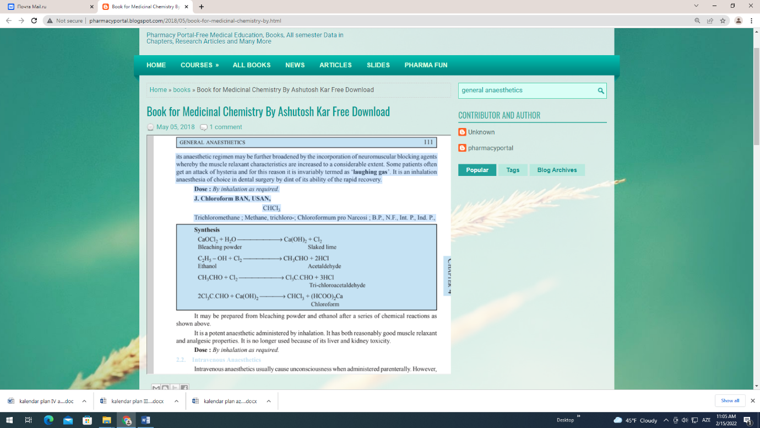
Trichloromethane ; Methane, trichloro-; Chloroformum pro Narcosi ; B.P., N.F., Int. P., Ind. P.,

It may be prepared from bleaching powder and ethanol after a series of chemical reactions as shown above. It is a potent anaesthetic administered by inhalation. It has both reasonably good muscle relaxant and analgesic properties. It is no longer used because of its liver and kidney toxicity.
Dose : By inhalation as required.
2.2. Intravenous Anaesthetics
Intravenous anaesthetics usually cause unconsciousness when administered parenterally. However, the duration of action can be safely monitored depending on the amount of drug administered. A few such potent intravenous anaesthetics shall be discussed here. A. Thiopental Sodium INN, USAN, Thiopentone Sodium BAN
Sodium 5-ethyl-5-(1-methylbutyl)-2-thiobarbiturate ; U.S.P., B.P., Eur. P., Int. P., Ind. P., Pentothal Sodium(R) (Abbott) ;
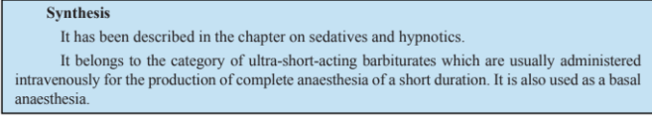
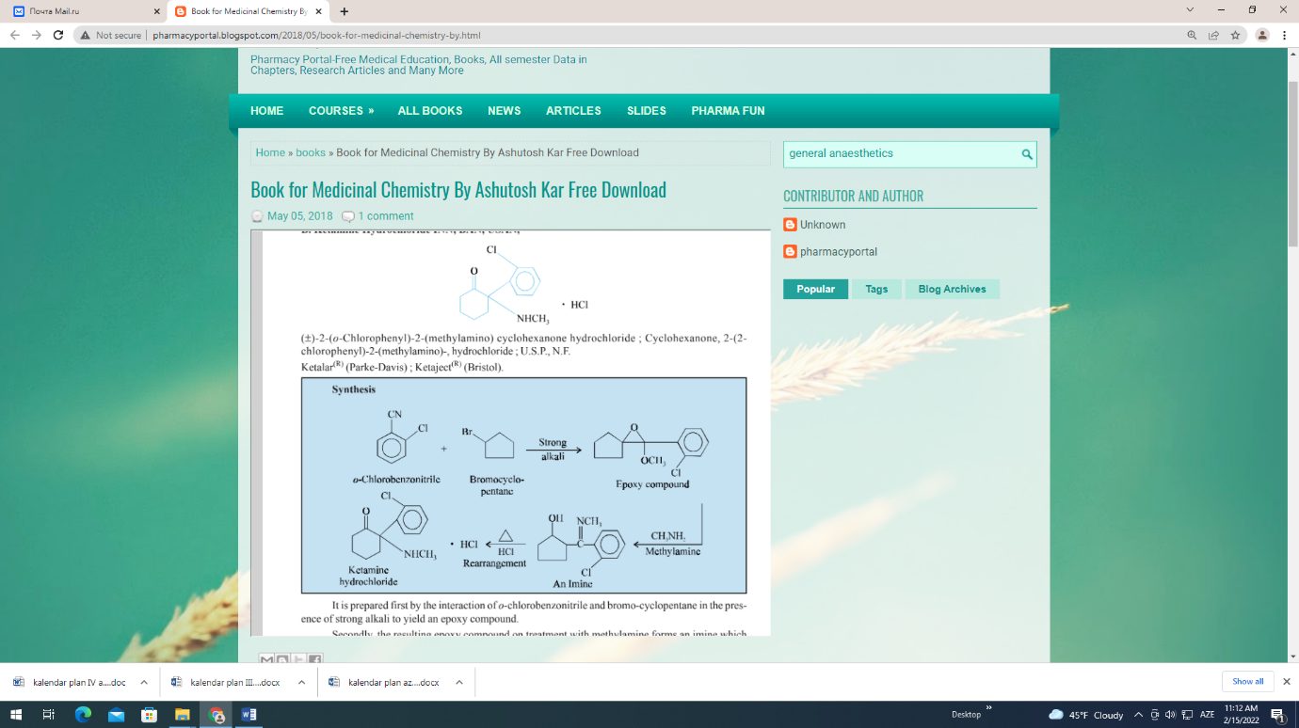

It is prepared first by the interaction of o-chlorobenzonitrile and bromo-cyclopentane in the pres-ence of strong alkali to yield an epoxy compound. Secondly, the resulting epoxy compound on treatment with methylamine forms an imine which undergoes molecular rearrangement upon heating in the presence of hydrochloric acid to yield ketamine hydrochloride. It is a rapid-acting general anaesthetic drug which causes anaesthesia accompanied by deep analgesia, slightly modified skeletal muscle tone and appreciable cardiovascular and respiratory stimulation. Of course, it is an intravenous anaesthetic agent of choice for surgical operations of short duration, but with additional doses it may effect anaesthesia for a span of 6 hours or even longer.
Dose : Induction, intravenous 1 to 4.5 mg/kg.
C. Methohexital Sodium USAN, Methohexitone Sodium BAN,
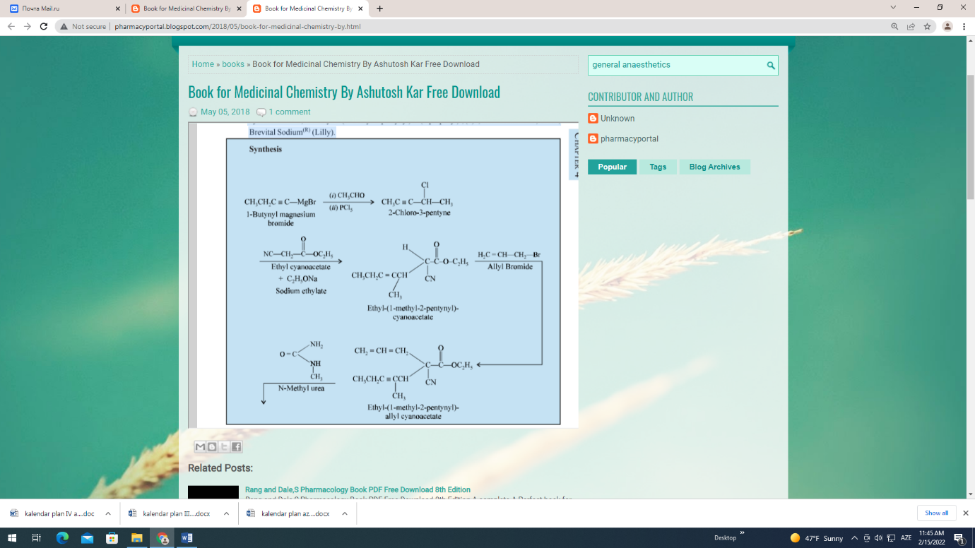
Sodium 5 allyl-1-methyl-5-(1-methyl-2-pentynyl) barbiturate ; 2, 4, 6 (1H, 3H, 5H)-Pyrimidinetrione, 1-methyl-5-(1-methyl-2-pentynyl)-5-(2-propenyl)-, (±)- , monosodium salt ; U.S.P., Brevital Sodium(R) (Lilly).
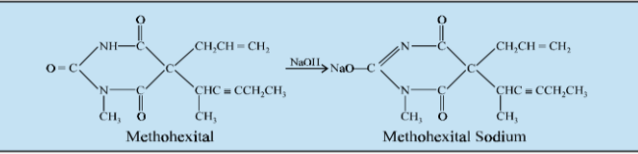
Grignardization of 1-butynyl magnesium bromide with acetaldehyde and subsequent treatment of the resulting alcohol with PCl5 yields 2-chloro-3-pentyne. Now, ethyl (1-methyl-2-pentynyl)-cyanoacetate is obtained therefrom by its condensation with ethyl cyanoacetate in the presence of sodium ethylate. Further condensation of the resulting product with allyl bromide gives rise to ethyl-(1-methyl-2-pentynyl) allylcyanoacetate. Condensation with N-methyl urea and subsequent neutralization with NaOH produces methohexital sodium.
It is used for the induction of anaesthesia through the intravenous administration. It has two advantages over thiopental sodium ; first, being its less affinity towards fatty tissues and secondly, its greater potency. Its onset of action is quite rapid comparable to thiopental sodium while its recovery is more rapid. For these reasons this intravenous anaesthetic is specifically useful for short surgical operation, such as : oral surgery, gynaecologic investigation, genitourinary procedures and eletroconvulsive therapy.
Dose : 5 to 12ml of 1% solution, at the rate of 1ml every 5 seconds ; usual intravenous
administration ; maintenance 2 to 4 ml every 4 to 7 min.
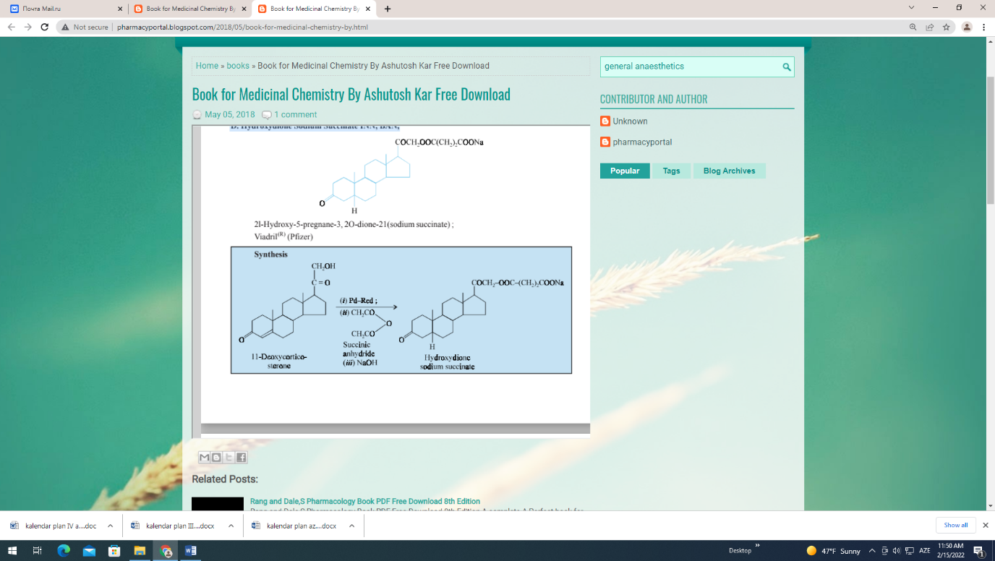
D. Hydroxydione Sodium Succinate INN, BAN,

It may be prepared first by the reduction of 11-deoxycorticosterone in the presence of palladium, secondly by treatment with succinic anhydride and thirdly the formation of its sodium salt from sodium hydroxide. It is a steroidal drug previously administered by intravenous route for the induction of anaesthesia. Its toxic effects range from causing respiratory depression, hypotension and venous irritation.
Dose : 0.5 to 1.5g.
E. Thiamylal Sodium USAN, Sodium Thiamylal BAN,
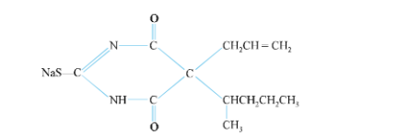

Sodium 5-allyl-5-(1-methylbutyl)-2-thiobarbiturate ; 4, 6-(1H, 5H)-Pyrimidine-dione, dihydro-5-(1-methylbutyl)-5-(2-propenyl)-2-thioxo-, monosodium salt ; U.S.P.,
Surital(R) (Parke-Davis) ;
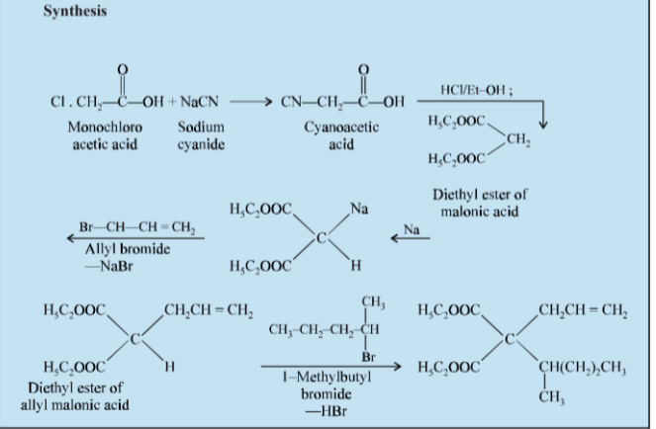

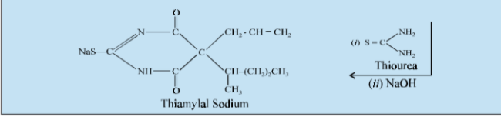
The cyanoacetic acid obtained from monochloroacetic acid and sodium cyanide, is treated with hydrochloric acid and ethanol to yield the diethyl ester of malonic acid. The ester, in absolute ethanol, is reacted with the stoichiometric proportion of metallic sodium so as to replace only one active hydrogen of the methylene (CH2) group. Thereupon, a slight excess of the calculated amount of allyl bromide is added. The second replaceable hydrogen is abstracted with 1-methyl butyl bormide and the resulting product is made to react with a theoretical amount of thiourea to yield thiamylal. The free acid thus obtained is conveniently transformed into the official sodium salt by neutralization with a stoichiometric proportion of sodium hydroxide (1 : 1).
It is an ultra-short acting barbiturate mainly used for intravenous anaesthesia in conditions of comparatively short-duration. It is also effective for the termination of convulsions of unknown origin. Dose : Usual, intravenous, 3 to 6 ml of 2.5% solution at the rate of 1 ml every 5 seconds ; maintenance dose being 0.5 to 1 ml as per requirement.
F. Propanidid INN, BAN, USAN,
Propyl {4-[(diethylcarbamoyl)-methoxy]-3 methoxyphenyl} acetate ; Benzene-acetic acid, 4-[2-(diethylamino)-2-oxoethyl]-3-methoxy-, propyl ester ; B.P.,
Epontol(R) (Bayer) :
It is an ultra-short acting anaesthetic which is administered intravenously either for producing complete anaesthesia of short duration or for induction of general anaesthesia. It is relatively less potent than thiopentone. It possesses neither analgesic nor muscle relaxant activities.
Dose : 5 to 10 mg per kg body weight, normally administered as a 5% solution.
2.3. Basal Anaesthetics
Basal anaesthetics are agents which induce a state of unconsciousness but the depth of
unconsciousness is not enough for surgical procedures. They are often used to induce basal anaesthesia before the administration of inhalation anaesthetics. They are also used for repeated short procedures in children like the changing of painful dressings. Basal anaesthetics offer three cardinal merit points, namely : devoid of mental distress, pleasant induction and lesser respiratory irritation. They are often administered through the rectum. Few deserve mention.
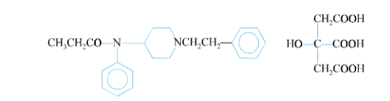
N-(1-Phenethyl-4-piperidyl) propionanilide citrate (1 : 1) ; Propanamide, N-phenyl-N-[1-(2-
phenylethyl)-4-piperidinyl]-, 2-hydroxy-1, 2, 3-propanetricarboxylate (1 : 1) ; B.P., U.S.P., Sublimaze(R) (Janssen) ; Innovar(R) (McNeil) ; It is employed basically as an analgesic for the control of pain associated with all kinds of surgery. It may also be used an an adjunct to all drugs commonly employed for regional and general anaesthesia. It is one of the components in ‘Fentanyl citrate and Droperidol Injection’ which is used as premedication for anaesthesia and also as an supplement for induction and maintenance of anaesthesia.
Dose : Usual, intramuscular, 0.05 to 0.1 mg 30 to 60 minutes before operation.
B. Tribromoethanol USAN, Tribromoethyl Alcohol BAN,

2, 2, 2-Tribromoethanol ; Tribromoethyl alcohol ; B.P. 1953, Int. P., N.F. XIII ;
Avertin(R) (Winthrop) ;
Synthesis

It is prepared by the interaction of a solution of bromine with aluminium ethoxide or preferably aluminium isopropoxide. It is a basal anaesthetic agent of choice which is administered through rectum in the form of its solution. The main advantage of such an anaesthesia being its pleasant induction amalgamated with lack of irritating vapours.
Dose : Usual, rectal, 60 to 80 mg/kg body weight, not more than 8 g for woman and 10 g for man. C. Paraldehyde BAN, USAN,
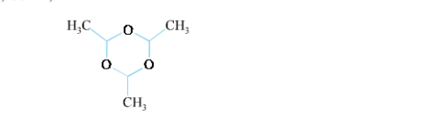

2, 4, 6-Trimethyl-s-trioxane ; 1, 3, 5-Trioxane, 2, 4, 6-trimethyl-; Paracetaldehyde ;
The trimer of acetaldehyde ; B.P., U.S.P., Eur. P., Ind. P.,
Paral(R) (O’Neal, Jones and Feldman) ;
Synthesis
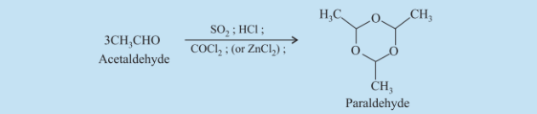
It may be prepared by treating acetaldehyde with small amounts of sulphur dioxide, hydrochloric acid, zinc chloride or carbonyl chloride, when almost complete conversion is caused. The resulting liquid is freezed and then distilling the crystallized substance under reduced pressure yields the pure paraldehyde.
It is one of the oldest and best hypnotics having anti-convulsant effects. It is sometimes used as an obstetrical analgesic, in which situation large doses are administered, usually through rectum.
Dose : Adult, oral, sedative 5 to 10 ml ; as hypnotic 10 to 30 ml ; Intra-muscular sedative, 5 ml ; hypnotic 10 ml.
Mode of action of general anaesthetıcs
General anaesthetics have been in use for more than a century, but unfortunately so far no exact mechanism of action has been put forward. Of course, a few theories, namely ; lipid, physical, biochemical, miscellaneous, Meyer-Overton, minimum alveolar concentration (MAC), stereochemical effects and ion-channel and protein receptor theories have been advocated from time to time in support of the mode of action of the general anaesthetics. These will be discussed briefly in this context.
3.1. Lipid Theory
There exists a direct relationship between the anaesthetic activity of an agent and its lipid solubility. It offers a reasonably acceptable correlation between anaesthetic activity (pharmacologic) of a compound and its oil/water or oil/gas partition coefficient (physical). This hypothesis rightly advocates that the site of action of anaesthetics is usually hydrophobic in nature. It may be anticipated that the greater the lipid solubility of an anaesthetic agent the higher would be its potency.
3.2. Physical Theory
An increase in the strength of the Van der Waals correlation factors exerts a positive improvement of anaesthetic potency. Likewise, the size of anaesthetic molecules is a determining factor for their ability to reach the site of action. Another school of thought suggests that anaesthesia commences when the critical space within the membrane is charged with the anaesthetic molecules.
3.3. Biochemical Theory
It has been observed that barbiturates normally interfere with the creation of high-energy products by decoupling oxidative phosphorylation. There also exists ample evidence to prove that the cerebral oxygen consumption gets decreased considerably in a human being treated with a variety of anaesthetic agents. This may be expatiated by the fact that naesthesia invariably retards the central nervous system activity thereby resulting in a diminished oxygen intake.
3.4. Miscellaneous Theory
According to one concept the decrease in surface tension caused by an anaesthetic is directly related to its potency. Another possible explanation may suggest a relationship between the anaesthetic action and the function and structure of membrane. However, many of these theories converge to a point indicating that the lipid portion of membranes is the site of anaesthesia. A good deal of factual information has been accumulated in connection with physical properties together with biochemical and physiological processes of anaesthetic agents, but unfortunately not a single theory proved and substantiated by experimental facts of anaesthesia is known.
3.5. Meyer-Overton Theory
Meyer and Overton put forward that the potency of a drug substance as an anaesthetic exhibited a direct relationship to its ability to attain lipid solubility, or oil-gas-partition coefficient*. They have studied various membrane-like lipids, octanol and olive oil to establish and determine the lipid-soluble properties of the ‘volatile anaesthetics’ that existed at that time. However, it has been observed critically the drug substances having reasonably high lipid solubility essentially needed appreciably lower concentrations [i.e., lower Minimum Alveolar Concentration (MAC)] to cause anaesthesia. It was suggested further that the possible interaction between the hydrophobic section of the membrane and the anaesthetic molecules afforted an apparent distortion of the former very close to the channels that particularly conducted Na⁺ ions. Thus, the membrane has been subjected to squeeze and bloat in onto the corresponding channel to bring about two distinct biological actions, namely :
(a) interference with sodium conductance, and
(b) interference with usual neuronal depolarization.
In short, the recent development in the field of protein : drug interactions has more or less challenged this theory squarely.
3.6. Minimum Alveolar Concentration (MAC)
MAC may be defined as — ‘‘the concentration at 1 atmosphere of anaesthetic in the alveoli required to produce immobility in 50% of adult patients being subjected to a surgical procedure.” It has been duly observed that a further increase to 30% MAC (i.e., 1.3 MAC) invariably affords apparent immobility in 99% subjects.
Mechanism: Probably at equilibrium, the prevailing concentration of a volatile anaesthetic in the alveoli is equal to that in the brain ; and consequently this particular concentration in the brain that very intimately exhibits the concentration at the site responsible for the anaesthetic activities. Therefore, the MAC of a volatile anaesthetic is most frequently employed as a reliable ‘yardstick’ to ascertain the exact potency of an individual general anaesthetic agent. Table-1 depicts the MAC values of several gaseous and volatile anaesthetics commonly put into practice nowadays.
Table 1. MACs Partition Coefficients and Metabolism of Volatile Anaesthetics
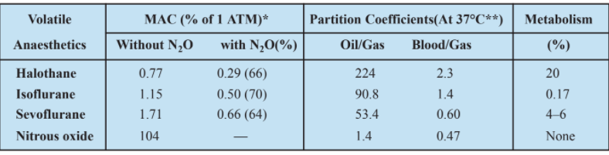
Interestingly, when these general (volatile) anaesthetics are employed in combination, the MACs for the Inhaled Anaesthetics are Additive.
Example : The intensity as well as depth accomplished with 0.5 MAC of enflurane together with 0.5 MAC of nitrous oxide is almost equivalent to what is produced by 1 MAC of either of the said two agents employed alone. The major advantage of such a combination being that a patient is not exposed to excessive quantum of any one of the individual agents, which in other words drastically minimises the probable risk of adverse reactions, if any.
3.7. Stereochemical Effects
It is pertinent to observe here that a number of volatile anaesthetics viz., halothane, isoflurane, enflurane and the like essentially contain in each of them an asymmetric carbon atom (i.e., a chiral centre) ; therefore, may invariably occur both as (+)-or (–)-enantiomers. It has been a common practice to make use of these volatile anaesthetics as their racemates commercially ; however, another school of thought devised a mean to establish and determine the anaesthetic characteristics of individual enantiomers. Salient Features : The following are some of the salient features of such investigations, namely :
(1) Lysco et al***. (1994) reported that (+)-isoflurane (MAC 1.06%) is approximately 50%more potent as an anaesthetic in the rat than its corresponding (–)-isoflurane compound
(MAC 1.62%).
(2) However, in another study by Graf et al.**** (1994) it was revealed beyond any reason-able doubt that the potency of the individual enantiomers to cause depression of mycardial activity was determined to be almost identical.
In short, the above findings in (1) and (2) evidently drive out attention to a rather more intricate and complex mechanism responsible for such distinct and apparent variations in their activities ; and that is the protein-anaesthetic interactions.*
3.8. Ion Channel and Protein Receptor Hypotheses
Importantly, a relatively more recent intensive studies have not only established but also helped in determining the cardinal effects of a host of volatile anaesthetics on a good number of protein receptors very much within the realm of central nervous system (CNS). The various characteristic features which critically and overwhelmingly support the possibility of an important and a vital interaction with a protein essentially include are, namely :
(a) Steep dose-response curves observed,
(b) Stereochemical requirements of different volatile anaesthetics,
(c) Observations with regard to enhanced molecular weight vis-a-vis lipid solubility profile of a general anaesthetic may eventually either decrease or negate absolutely the desired anaesthetic activity, and
(d) Revelations that the presence of particular ion channels and nerotransmitter receptor sys- tems are a vital need and basic requirements for a plethora of the noticeable activities of the volatile anaesthetics.
Mechanism: The most pivotal theme to explain the actual mechanism of action of volatile (general) anaesthetics logically and legitimately involves the interaction of the anaesthetics with the receptors which critically regulate the performance of the ion-channels, such as : K+, Cl–; or with theion-channel in a direct fashion (e.g., Na+).
MECHANISM OF ACTION OF GENERAL ANAESTHETICS
The probable mechanism of action of certain general anaesthetics dealt with in this chapter are enumerated as under :
4.1. Ethyl Chloride
An extremely volatile liquid with an agreeable pleasant odour. When sprayed on the skin, it evaporates so rapidly that the tissue is cooled immediately. By virtue of this characteristic property, the skin gets anaesthetized ; and hence, used in minor surgery for very short durations.
4.2. Vinyl ether
An anaesthetic agent which has become virtually obsolete because it is explosive or highly in-flammable in the concentration needed to cause anaesthesia.
4.3. Cyclopropane
It also enjoyed some popularity earlier, but has to be abandoned because of its highly explosive nature just like diethyl ether.
4.4. Fluroxene
It is a fluorinated unsaturated ethereal compound showing a rapid on-set of action by inhalation.
4.5. Halothane
It is a noninflammable, nonexplosive fluorinated volatile anaesthetic which is invariably mixed with either air or oxygen. Importantly, the presence of the C and halogen bonds generously contributes to its noninflammability nature. It was so designed to accomplish certain characteristic properties, namely :
(a) chemical stability ; (b) exert an intermediate blood solubility ; and (c) appreciable anaesthetic potency. Nevertheless, it is the only useful general anaesthetic having a bromine atom, which is exclusively responsible for its enhanced potency. Likewise, the presence of three strategically positioned in halothane is believed to increase its inherent potency, volatility and chemical stability of the hydrocarbon structure to a considerable extent.
Salient Features :
(i) It exhibits a rapid onset of action followed by rapid recovery from the induced anaesthetic effect in two different situations ; first, when used alone with high potency ; and secondly, when used in combination along with nitrous oxide.
(ii) A large number of metals, with the exception of chromium (Cr), nickel (Ni) and titanium (Ti), are very quickly tarnished (to lose lustre) by it.
(iii) Though it is comparatively stable ; however, it undergoes spontaneous oxidative decom-position resulting into the formation of hydrobromic acid (HBr), hydrochloric acid (HCl), and phosgene (COCl2). Therefore, it is specifically dispensed in dark-amber coloured glass containers with the addition of ‘thymol’ as a preservative to reduce the chances of oxidation.
(iv) It has observed duly that nearly 20% of an administered dosage of ‘halothane’ gets me-tabolized that ultimately is responsible for the enhanced observed hepatotoxicity.
4.6. Methoxyflurane
A general anaesthetic usually administered by inhalation for surgical procedures of relatively short duration. Its renal toxicity prevents its being used for prolonged anaesthesia.
4.7. Trichloroethylene
It is mostly used as an analgesic and anaesthetic agent to supplement the action of nitrous oxide.It should not be used with epinephrine.
4.8. Nitrous Oxide
The tasteless, odourless and colourless and sweet smelling N2O (‘laughing gas’) having minimum alveolar concentration (MAC) value almost exceeding 105% is observed to be incapable of inducing surgical anaesthesia if administered alone. It has already been established for N₂O to have an MAC value ranging between 105–140% ; and, therefore, is not able to succeed in accomplishing in ‘surgical anaesthesia’ under conditions prevailing at standard barometric pressure. Interestingly, Bert in 1879 demonstrated that an MAC more than 100% could be achieved by employing an admixture of 85% N₂O with O₂ at 1.2 atmospheres in a pressurized vessel, which would provide an MAC fairly sufficient for causing ‘surgical anaesthesia’. In fact, N₂O is usually employed alone as an anaesthetic agent during some special localized‘dental procedures’ only. However, most frequently N2O is utilized with other volatile anaesthetics to cause a sufficient desirable depth of anaesthesia essentially required for various ‘surgical procedures’.
Mechanisms :
Importantly, to date no definite mechanism(s) have been put forward to explain how nitrous oxide exerts its anaesthetic activity.
While some theories have been advocated which probably suggest the ‘irreversible oxidation’of the cobalt atom in vitamin B12 by the help of N2O that may ultimately render the inactivation of certain specific enzymes* dependent on Vit B12 having resultant deviations from its normal course.
4.9. Chloroform:

It has been established that the addition of halogens to the hydrocarbon backbone not only enhances potency but also retards flammability to a great extent. Chloroform (CHCl3) is a very potent anaesthetic agent having appreciable analgesic and neuromuscular relaxing activity. It is a known ‘carcinogen’ and proved to be both hepatotoxic and nephrotoxic ; besides, causing severe adverse circulatory effects, for instance : arrythmias and hypotension. Hence, by virtue of its absolutely unacceptable therapeutic index it is no longer used as a volatile anaesthesia.
4.10. Thiopental Sodium
Thiopental sodium belonging to the class of ultrashort-acting barbiturates (e.g., thiopental) are mostly employed IV to cause a rapid on set of unconsciousness for both surgical and basal anaesthesia.
Importantly, it may be used first and foremost to cause anaesthesia, which subsequently should beadequately subtained as well as maintained in the course of a surgical operative procedure with the aid of a general anaesthetic.
Mechanism: Barbiturates, in general, afford a marked decrease in the specific functional activities in the brain. They are found to increase considerably the GABAergic inhibitory response, by categorically influencing conductance at the chloride channel (just like the benzodiazepines). It has been observed that at a relatively higher doses, these may cause potentiation of the existing GABAA–mediated chloride ion conductance, thereby strengthening the bondage between GABA andbenzodiazepine.
Another school of thought suggests the following mechanisms of barbiturates, such as (a) uncoupling of oxidative phosphorylation ; (b) prevention of the electron-transport system ; and (c) inhibition of the prevailing cerebral carbonic-anhydrase activity ; occurring all at relatively higher concentrations. Barbiturates are also found to induce liver microsomal enzymes which may invariably lead to an enhanced rate of biotransformation of a host of other commonly employed drugs. They alsoexert an appreciable affect on the transport of sugars in vivo.
4.11. Ketamine hydrochloride
It is an extremely potent fast-acting anaesthetic agent and having comparatively short duration of action (10–25 minutes).
Mechanism:
(i) It does not relax skeletal muscles ; and hence, it may be employed safely in such cases of short-duration wherein muscle-relaxation is not needed at all.
(ii) Cessation of the acute action is caused mostly due to its redistribution from the brain into other tissues of the body.
(iii) It has been observed that a plethora of ‘metabolites’ invariably occur on account of the formation of the glucoronide conjugate and metabolism in the liver.
(iv) Norketamine, a metabolite is generated via the action of cytochrome P450. Interestingly, this particular demethylated structural analogue does retain an appreciable activity at the site of the N-methyl-D-aspartate (NDMA) receptor, which may eventually be respon-sible for attributing towards the longer duration of action of this anaesthetic drug.
Norketamine gets converted to its corresponding hydroxylated metabolites which upon further conjugation form certain metabolites that gets eliminated through the kidney.
(v) Ketamine is believed to act very much alike the phencyclidine (PCP) that essentially serves as an antagonist very much within the cationic channel of the NDMA-receptor complex*. By preventing the flow of cations through the cationic channel, it evidently checks neuronal activation that is usually needed for holding the conscious state.
(vi) It is largely able to sustain and produce a ‘dissociative’ anaesthesia, that is particularly characterized by electraencephalogram (EEG) alterations thereby showing a marked and pronounced dissociation occurring between the thermocortical and limbic systems**.
(vii) Ketamine’s analgesic activity could be due to an interaction either with an opioid receptor or a sigma receptor (which is relatively not-so-well understood).
4.12. Hydroxydione sodium succinate
It is basically a steroidal drug used intravenously as an anaesthetic agent. It has, however, no hormonal activity.
4.13. Thiamylal Sodium
Thiamylal is a highly hydrophobic thiobarbiturate having its structural features very much related to thiopental. Besides, its biological activities are almost identical to thiopental. After IV administration, unconsciousness is induced within a span of a few seconds only, while complete recovery of consciousness occurs within 30 minutes. Therefore, it is mostly used effectively in short surgical procedures.
4.14. Fentanyl citrate
Fentanyl citrate is a potent narcotic analgesic with rapid onset and short duration of action when administered parenterally. It shows a profile of pharmacological action quite similar to morphine, but with two glaring exceptions, namely : (a) does not cause emesis ; and (b) releases histamine. After IV administration, the peak analgesia seems to occur within a span of 3–5 minutes and lasts for 30–60 minutes. Interestingly, it is employed primarily as an analgesic for the acute control and management of pain associated with all types of surgery. It also finds its enormous application as a supplement to all such agents that are invariably used either for general and regional anaesthesia.
Advantage: The administration of ‘fentanyl’ (i.e., the base) via a transdermal patch exhibits a much slower onset (8 to 12 hours) and significantly longer duration of action (more than 72 hours) ; and, therefore , quite frequently is employed to manage chronic pain that essentially requires an ‘opiate analgesic’.
4.15. Paraldehyde
It is one of the ‘oldest sedatives and hypnotic’ which gets absorbed very quickly after oraladministration and helps to induce sleep within 10–15 minutes after a 4-to 8-mL dose. Its application has been resticted in patients with a history of asthma or other pulmonary diseases because it gets
Local Anaesthetics
Local anaesthetics are drugs which reversibly prevent the generation and the propagation of active potentials in all excitable membranes including nerve fibres by stabilizing the membrane. They achieve this by preventing the transient increase in sodium permeability of the excitable membrane.
Generally, small diameter cells are more sensitive to their action than larger diameter cells. Thus conduction in nerve fibres is more readily blocked than conduction in muscle fibres. Also usually the smaller diameter nerve fibres are more susceptible to the action of local anaesthetics than the larger diameter ones. For example, on a mixed sensory fibre, local anaesthetic will abolish conduction on the fibre conveying the sensation of pain first. This will be followed by block of the fibre responsible for the sensations of cold, warmth, touch and deep pressure in that order. This is in accordance with the fibre diameter. It is important to mention here that fibre diameter though very important is not always the only factor that determines the relative sensitivity of the nerve fibres to the action of the local anaesthetics.
It is, however, pertinent to mention here that both ‘local anaesthetics’ and ‘general anaesthetics’essentially afford anaesthesia by blocking nerve conductance in motor neurons as well as sensory neurons.
The ultimate blockade of nerve conduction causes not only a loss of pain sensation but also affects impairment of motor functions. Interestingly, the anaesthesia produced by the ‘local anaesthetic does not necessarily cause complete loss of either consciousness or significant impairment of important central functions. It is, however, believed that ‘local anaesthetics’ normally exert their action by blocking nerve conductance after having bondage to selective site(s) of the Na-channels in the particular excitable membranes. In this manner, the passage of Na through the pores gets reduced significantly and hence cause direct interference with the action potentials. Evidently, a local anesthetic helps in drastically minimising the excitability of the nerve membranes with touching the resting potentials. In short, local anaesthetics neither interact with the pain receptors nor affect the biosynthesis of pain mediators.
Local anaesthetics are used to abolish the sensation of pain in a restricted area of the body and for minor surgical operations when loss of consciousness is not desirable. The area is determined by the site and the technique of administration of the anaesthetic agent. The main uses are as follows :
(a) Surface or Topical Anaesthesia
The local anaesthetic is applied to the mucous membrane, .e.g., conjunctiva, larynx, throat, damaged skin surface, etc.
(b) Infiltration Anaesthesia
The drug is injected subcutaneously to paralyse the sensory nerve endings around the area to be rendered insensitive, e.g., an area to be incised or for tooth extraction.
(c) Nerve Block Anaesthesia
The local anaesthetic is injected as close as possible to the nerve trunk supplying the specific area to be anaesthetised. This blocks conduction in both sensory and motor fibres and minor operations on the limb are possible.
(d) Spinal Anaesthesia
The drug is injected into the subarachnoid space, i.e., into the cerebrospinal fluid, to paralyse the roots of the spinal nerves. This method is used to induce anaesthesia for abdominal or pelvic surgical operations.
Saddle block is a variation of spinal anaesthesia where the injection is made into the lower part of the subarachnoid space. The drug normally settles in the lower part of the dural space. It is used in obstetrics and for surgery in the perineal region.
(e) Epidural Anaesthesia
This is a special type of nerve block anaesthesia in which the drug is injected into the epidural space. It is technically a more difficult procedure. The roots of the spinal nerves are anaesthetized.
(f) Caudal Anaesthesia
This is smaller to epidural anaesthesia where the injection is made through sacral hiatus into the vertebral canal which contains the cauda equina. It is used for operations on the pelvic viscera.
The first local anaesthetic to be used was cocaine as alkaloid isolated from the leaves of Erythroxylon coca (Erythroxylum coca). Carl Koller,1 an Australian ophthalmologist in 1884, made an epoch making observation that cocaine hydrochloride causes anaesthesia in the eye. A follow-up byWillsttter and Mller² towards an elaborated elucidation of the structure of cocaine ultimately paved the way to the synthesis of a large number of compounds exhibiting local anaesthetic characteristics.
The scheme shown as under, represents the formation of active benzoyl ecognine and tropocaine from cocaine and inactive ecognine and pseudo tropane therefrom.
The portion of the cocaine molecule enclosed by a dotted line in the above scheme represents the ‘anaesthesiophoric moiety’ and may be designed by the general structure : Ar—COO—(CH2)n NR1R2.
The next step in the advance of the knowledge of anaesthesia was the recognition that the presence of a basic nitrogen atom in the esterified alcohol was highly desirable. It permitted the formation of the neutral salt, solutions of which could be injected conveniently and it might also influence the anaesthetic activity effectively.
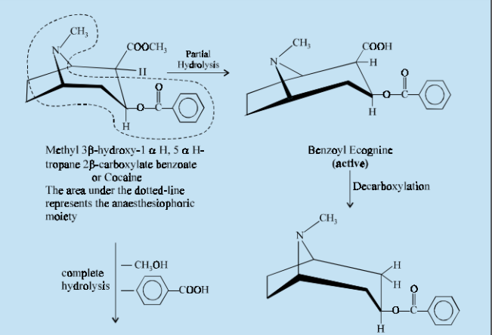
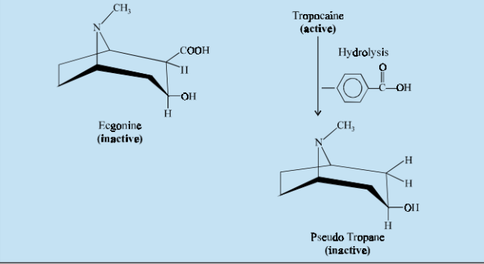
Einhorn generalised that all aromatic esters possess the ability to cause anaesthesia and hence he prepared two types of esters, namely :
(a) Methyl ester of p-amino-m-hydroxy benzoic acid
(b) Methyl ester of m-amino-p-hydroxy benzoic acid
This generalization eventually led to the preparation of a large number of analogous esters. It was, however, observed that esters of higher alkyl groups and those with the normal chains are most active. During the period 1904 to 1909, several esters of basic alcohols with benzoic acid were prepared, viz., amylocaine (1904), procaine (1906) and orthoform (1909).
2. CLASSIFICATION
The local anaesthetics may be classified on the basis of their ‘chemical structures’ as described below :
2.1. The Esters
The earlier observations made by Einhorn really stimulated research towards the synthesis of a number of benzoic acid esters which exhibited significant local anaesthetic properties. A few important esters are described below :
Examples : Ethyl-p-amino benzoate ; Butamben ; Orthocaine ; Procaine Hydrochloride ; Tetracaine Hydrochloride ; Butacaine Sulfate ; Cyclomethycaine Sulphate ; Proxymetacaine Hydrochloride ; Propoxycaine Hydrochloride ; Hexylcaine Hydrochloride, etc. A. Ethyl p-aminobenzoate INN, Benzocaine BAN, USAN,
Benzoic acid, 4-amino-, ethyl ester ; Ethyl Aminobenzoate ; B.P., U.S.P., Eur. P., Int. P., N.F., Ind. P., Americaine(R) (American Critical Care) :
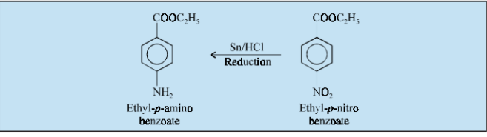

p-Nitrobenzoic acid, may be prepared by nitration of toluene and oxidation of the resulting p-nitrotoluene, is esterified to the corresponding ethyl ester by heating with absolute ethanol and a few drops of sulphuric acid. The resulting ethyl p-nitrobenzoate is reduced with tin and hydrochloric acid to give the official compound.
Being insoluble it is generally used as an ointment to get rid of the pain caused due to wounds, ulcers and mucous surfaces. Its anaesthetic action is usually displayed for the period it remains in contact with the skin or mucosal surface. Hence, it forms an important ingredient in various types of creams, ointments, powders, lozenges and aerosol sprays so as to relieve the pain of naked surfaces and severely inflamed mucous membranes.
Dose : Topical, 1 to 20% in ointment, cream, aerosol for skin.
B. Butamben USAN, Butyl Aminobenzoate BAN,
Butyl p-aminobenzoate ; Benzoic acid, 4-amino-, butyl ester ; U.S.P., N.F. XIII ;
Butesin(R) (Abbott).
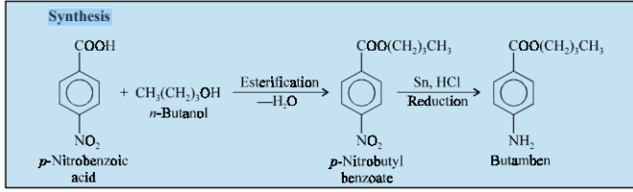
It may be prepared by the esterification of p-nitrobenzoic acid with n-butanol, then reducing the nitro group with tin and hydrochloric acid. It is a local anaesthetic of relatively low solubility and used in a similar manner to benzocaine. It has been reported to be more efficacious than its corresponding ethyl ester when applied to intact mucous membranes.
Dose : Topical, 1 to 2% in conjunction with other local anaesthetics in creams, ointments, sprays and suppositories.
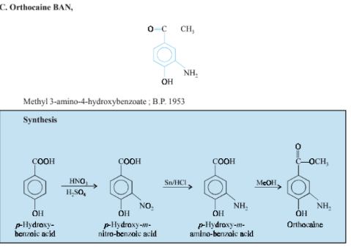
p-Hydroxy-m-aminobenzoic acid is obtained by the nitration and reduction of p-Hydroxy benzoic acid, which on esterification with methanol yields orthocaine.
It is used for surface anaesthesia, but now it is obsolete due to its irritation and necrosis effects.
D. Procaine Hydrochloride BAN, USAN,
2-(Diethylamino) ethyl-p-aminobenzoate hydrochloride ; Benzoic acid, 4-amino-, 2-(diethylamino) ethyl ester, monohydrochloride ; Ethocaine hydrochloride ; Allocaine ; Syncaine ; B.P. U.S.P.,
Eur. P. Int. P., Ind. P.,
Novocaine(R) (Sterling) ;
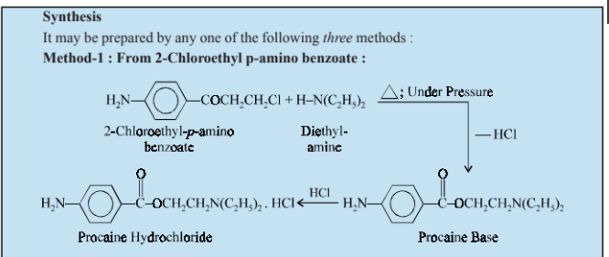

Procaine base may be prepared by the interaction of 2-chloro ethyl-p-amino benzoate and diethylamine at an elevated temperature under pressure. The base is converted into its hydrochloride subsequently.
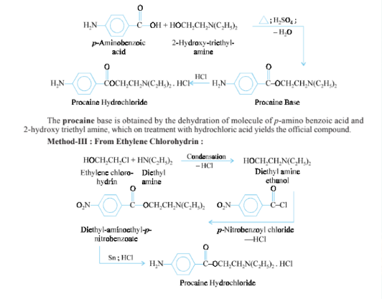
Method-II : From p-Aminobenzoic Acid:

Condensation of a molecule each of ethylene chlorohydrin and diethyl amine yields diethyl amino ethanol, which on treatment with a mole of p-nitrobenzoyl chloride gives rise to diethyl amino ethyl-p-nitrobenzoate. This on reduction with tin and hydrochloric acid yields the procaine hydrochloride.It is one of the least toxic and most commonly used local anaesthetics. The salient features for its wide popularity may be attributed due to its lack of local irritation, minimal systemic toxicity, longer duration of action, and low cost. It can be effectively used for causing anaesthesia by infiltration, nerve block, epidural block or spinal anaesthesia. In usual practice it is used in a solution containing adrenaline (1:50,000) which exerts and modifies the local anaesthetic activity through retarded absorption, and the duration of action is considerably prolonged.
Dose : Usual, infiltration, 50 ml of a 0.5% solution ; usual, peripheral nerve block, 25 ml of a 1 or 2% solution ; usual, epidural, 25 ml of a 1.5% solution.
E. Tetracaine Hydrochloride INN, USAN, Amethocaine Hydrochloride BAN,

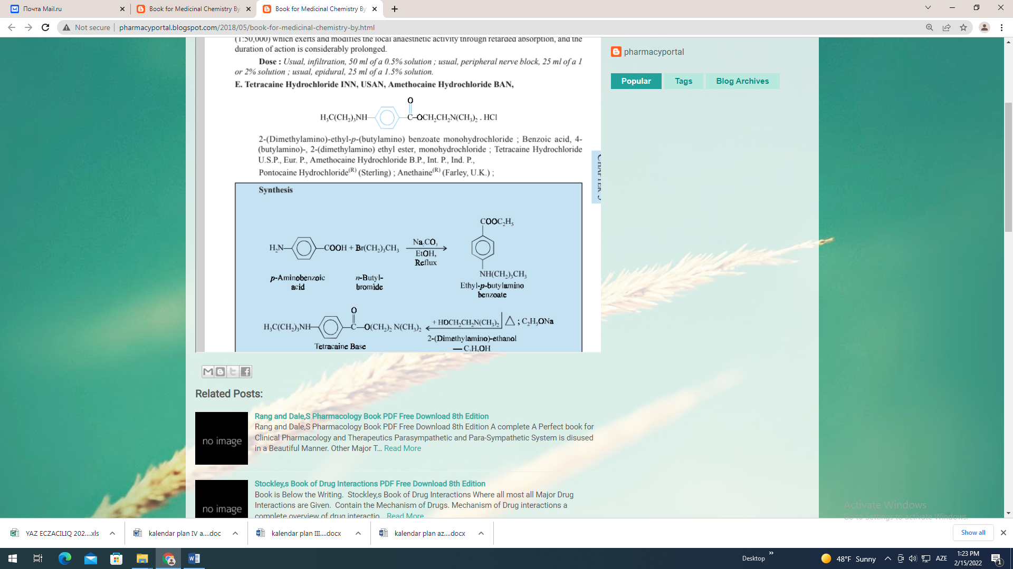
2-(Dimethylamino)-ethyl-p-(butylamino) benzoate monohydrochloride ; Benzoic acid, 4-(butylamino)-, 2-(dimethylamino) ethyl ester, monohydrochloride ; Tetracaine Hydrochloride U.S.P., Eur. P., Amethocaine Hydrochloride B.P., Int. P., Ind. P., Pontocaine Hydrochloride(R) (Sterling) ; Anethaine(R) (Farley, U.K.) ;

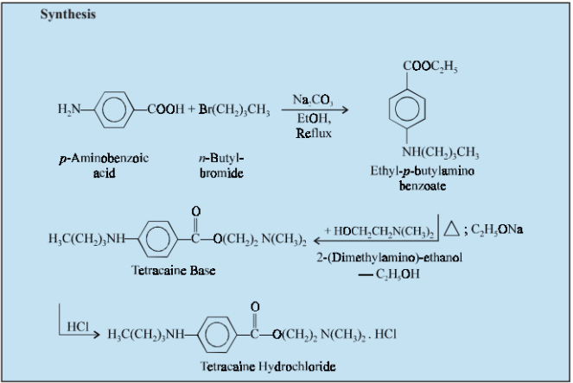
Butylation of p-aminobenzoic acid with n-butyl bromide under reflux in ethanolic solution and in the presence of sodium carbonate yields ethyl-p-butylamino benzoate. This is then caused to undergo transesterification by heating a solution of it in 2-(dimethylamino) ethanol in the presence of sodium ethoxide in such a manner that the liberated ethanol is continuously removed from the reaction mixture by distillation. The tetracaine base is dissolved in benzene and hydrogen chloride is passed through the solution to obtain the corresponding monohydrochloride salt. It is an all-purpose local anaesthetic drug used frequently in surface infiltration, block, caudal and spinal anaesthesia. It is reported to be 10 times more toxic and potent than procaine, whereas its duration of action is twice than that of procaine.
Dose : Usual, subarachnoid 0.5 to 2 ml as a 0.5% solution ; topically, 0.1 ml of a 0.5% solution to the conjunctiva.
F. Butacaine Sulfate USAN, Butacaine Sulphate BAN, Butacaine INN,
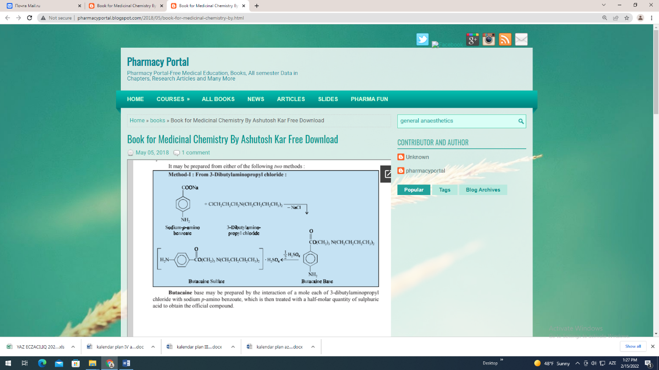

Butacaine base may be prepared by the interaction of a mole each of 3-dibutylaminopropyl chloride with sodium p-amino benzoate, which is then treated with a half-molar quantity of sulphuric acid to obtain the official compound.
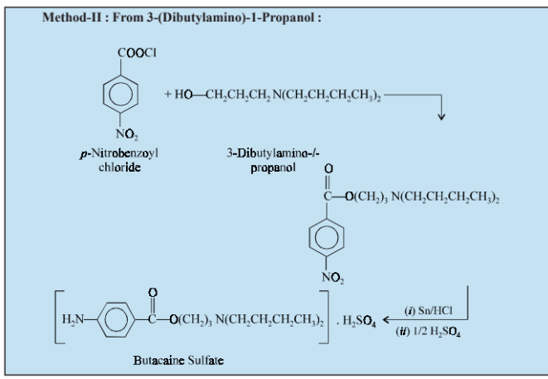
3-(Dibutylamino)-1-propanol is coupled with p-nitrobenzoyl chloride and the corresponding nitro group is subsequently reduced to amino by treatment with tin and hydrochloric acid. The resulting butacaine base is made to react with a half-molar quantity of sulphuric acid.
It is a surface anaesthetic having effects similar to those of cocaine, but it exhibits more rapid onset of action followed by a prolonged action.
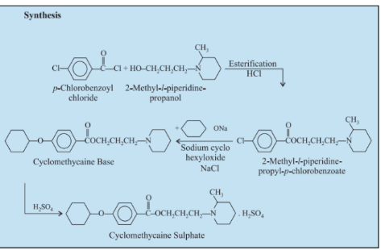
Dose : Several instillations of a 2% solution about 3 minutes apart allow most surgical procedures.G. Cyclomethycaine Sulphate BAN, Cyclomethycaine Sulfate USAN, Cyclomethycaine INN,
p-Chlorobenzoyl chloride undergoes esterification with 2-methyl-1-piperidinepropanol with the elimination of a mole of hydrogen chloride. This on treatment with sodium cyclohexyl oxide yields the cyclomethycaine base which on further treatment with sulphuric acid gives the official compound.
It is extensively used as an effective topical anaesthetic in thermal and chemical burns ; in dermatological lesions, sunburn and skin abrasions ; in urology, gynaecology, obstetrics and anaesthetic procedures.
Dose : Topical, 0.25 to 1.0% in suitable form.
H. Proxymetacaine Hydrochloride BAN, Proxymetacaine INN, Proparacaine Hydrochloride USAN,
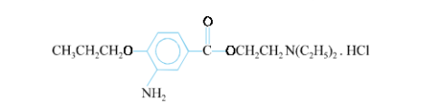
2-(Diethylamino) ethyl 3-amino-4-propoxybenzoate monohydrochloride ; Benzoic acid, 3-amino-4-propoxy-, 2-(diethylamino)-ethyl ester, monohydrochloride ;
Proxymetacaine Hydrochloride B.P.C. (1973) ; Proparacaine Hydrochloride U.S.P.
Alcaine(R) (Alcon) ; Ophthaine(R) (Squibb) ; Ophthetic(R) (Allergan)
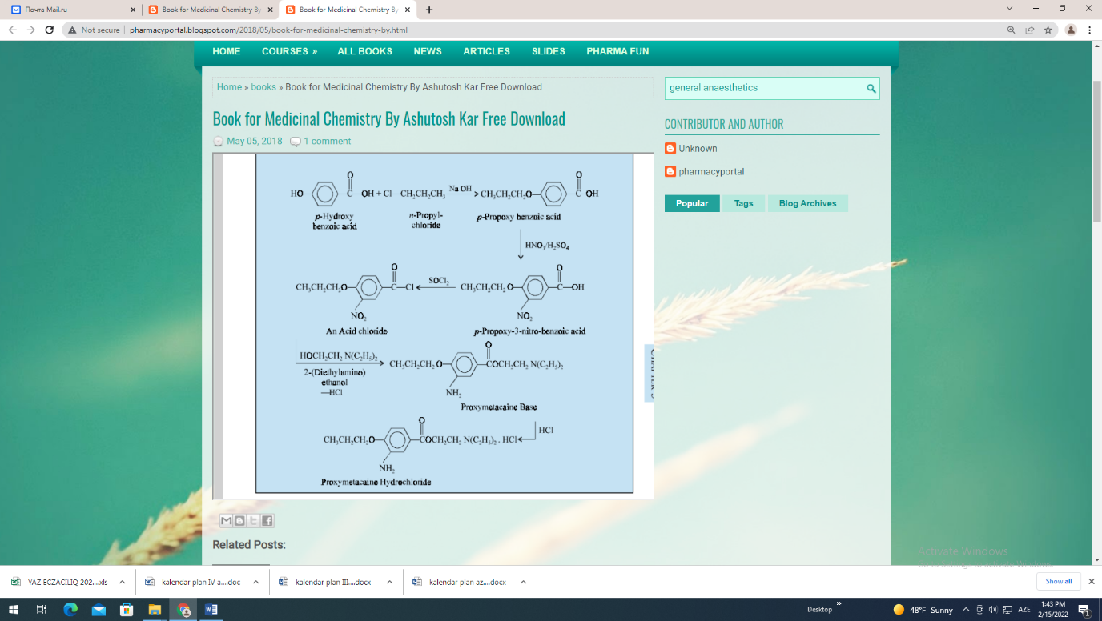
p-Propoxybenzoic acid is obtained by the interaction of p-hydroxy benzoic acid and
n-propylchloride in an alkaline medium, which on nitration yields the corresponding 3-nitro analogue. Subsequent treatment with thionyl chloride yields an acid chloride which is then coupled with 2-(diethylamino) ethanol yields the proxymetacaine base. This on reaction with an equimolar quantity of HCl gives the official compound.
It is a potent surface anaesthetic mainly used in ophthalmology and induces no initial irritation. Because of its rapid onset of action it is useful for most occular procedures that require topical anaesthesia such as tonometry, removal of foreign particles, gonioscopy and various short operative procedures which may involve the conjunctiva and cornea. It has also been reported to be employed frequently as a surface anaesthesia in glaucoma surgery and in cataract operations.
Dose : Topical, 0.05 ml of a 0.5% solution to the conjunctiva.
- Propoxycaine Hydrochloride BAN, USAN, Propoxycaine INN,
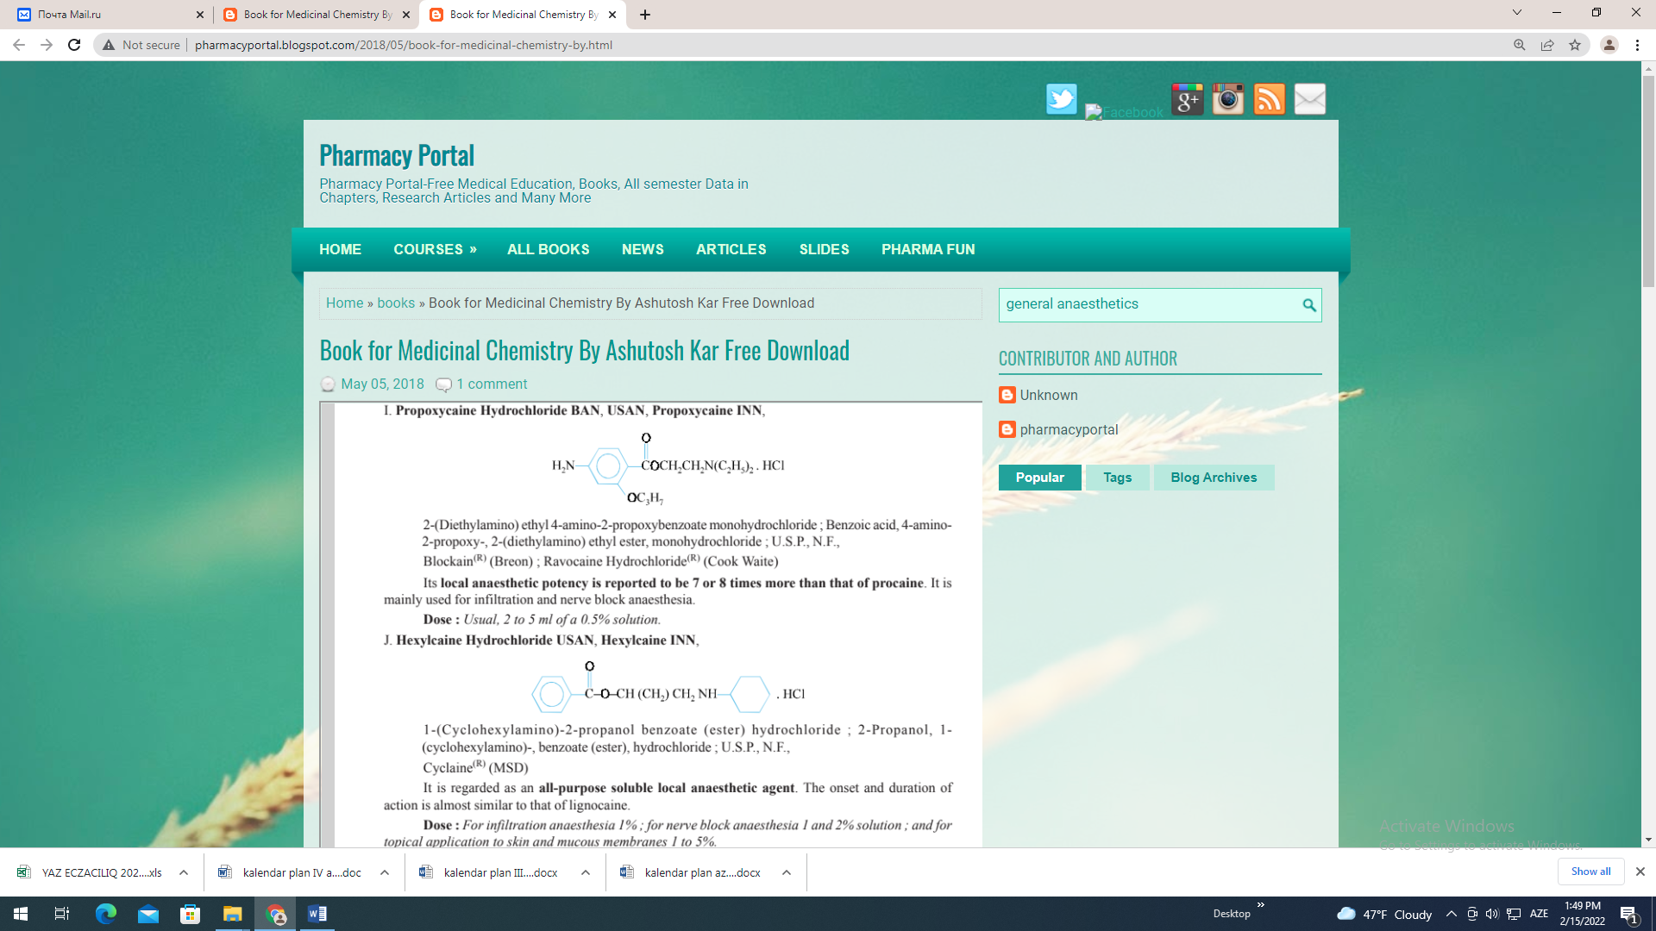
2-(Diethylamino) ethyl 4-amino-2-propoxybenzoate monohydrochloride ; Benzoic acid, 4-amino-2-propoxy-, 2-(diethylamino) ethyl ester, monohydrochloride ; U.S.P., N.F.,
Blockain(R) (Breon) ; Ravocaine Hydrochloride(R) (Cook Waite)
Its local anaesthetic potency is reported to be 7 or 8 times more than that of procaine. It is mainly used for infiltration and nerve block anaesthesia.
Dose : Usual, 2 to 5 ml of a 0.5% solution.
J. Hexylcaine Hydrochloride USAN, Hexylcaine INN,
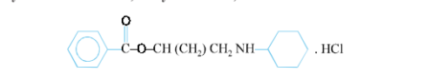

1-(Cyclohexylamino)-2-propanol benzoate (ester) hydrochloride ; 2-Propanol, 1-
(cyclohexylamino)-, benzoate (ester), hydrochloride ; U.S.P., N.F.,
Cyclaine(R) (MSD)
It is regarded as an all-purpose soluble local anaesthetic agent. The onset and duration of action is almost similar to that of lignocaine.
Dose : For infiltration anaesthesia 1% ; for nerve block anaesthesia 1 and 2% solution ; and for topical application to skin and mucous membranes 1 to 5%.
2.2. Piperidine or Tropane Derivatives
The members of this particular group of compounds essentially contain the piperidine nucleus. Examples : α-Eucaine ; Benzamine Hydrochloride ; Euphthalmin A. α-Eucaine
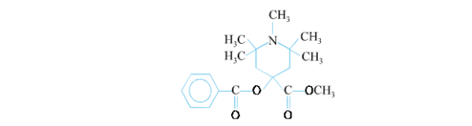
2, 2, 6, 6-Tetramethyl-4-benzoxy-4-methyl carboxylate-N-methyl piperidine.

Triacetoneamine is first prepared by the condensation of three moles of acetone with one mole of ammonia. This on methylation with dimethyl sulphate yields the corresponding N-methyl triacetoneamine which on treatment with hydrocyanic acid gives cyanohydrin analogue. Finally, when the resulting product is subjected to hydrolysis, followed by benzoylation and esterification with methanol yields α-eucaine.
It is comparatively less toxic than cocaine, but is more painful and irritant than the later and hence ; it has been replaced by β-eucaine.
B. Benzamine Hydrochloride BAN
Diacetone alcohol is obtained by the Aldol condensation of two moles of acetone in the presence of barium hydroxide. On dehydration diacetone alcohol yields mesityl oxide, which upon amination gives diacetoneamine. This on treatment with diethyl acetal undergoes cyclization with the elimination of two moles of ethanol to give vinyl diacetoneamine. The cyclized product on reduction followed by benzoylation and treatment with hydrogen chloride yields benzamine hydrochloride. It is a local anaesthetic formerly used for surface anaesthesia. Its anaesthetic property is fairly
comparable to that of cocaine.
Vinyl diacetoneamine is prepared by the same method as described for benzamine hydrochloride
above, which on reduction with (sodium-amalgam) yields vinyl diacetone alkamine. This on treatment
with dimethylsulphate and sodium hydroxide yields the N-methyl derivative. The resulting product on
treatment with mandelic acid undergoes esterification to yield euphthalmin.
2.3. The Amides
The earlier usage of acetanilide and methylacetanilide (exalgin) in the therapeutic armamentarium as antipyretic and analgesic drugs strongly advocate the idea and belief that when the COCH3 moiety of these simple amides is further extended to the COCH2NR2NR2, the resulting compounds offer remarkable local anaesthetic properties. This, in fact, led to synthesis of a large number of compounds of the amide type and a few classical examples are described below.
Examples : Lignocaine Hydrochloride ; Prilocaine Hydrochloride ; Mepivacaine
Hydrochloride ; Bupivacaine Hydrochloride ; Pyrrocaine Hydrochloride ; Diperodon.
A. Lignocaine Hydrochloride BAN, Lidocaine INN, Lidocaine Hydrochloride USAN.
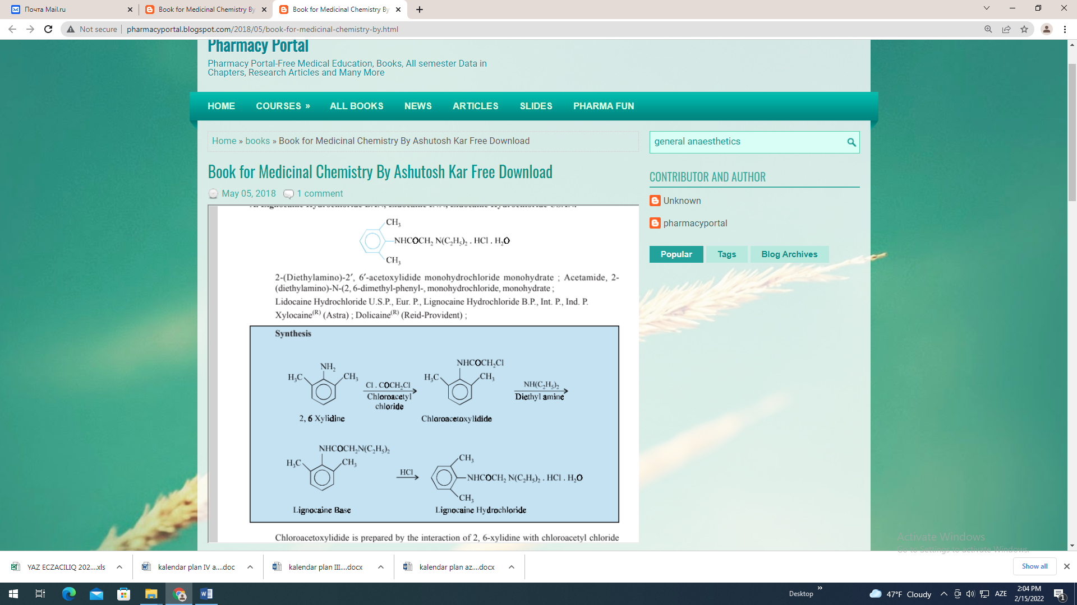

Chloroacetoxylidide is prepared by the interaction of 2, 6-xylidine with chloroacetyl chloride which on treatment with diethylamine yields the lignocaine base. This when treated with an equimolar quantity of hydrochloric acid gives the respective lignocaine hydrochloride. It is a potent local anaesthetic and is reported to be twice as active as procaine hyrdrochloride in the same concentration. A 0.5% solution is toxic, but at 2% its toxicity is increased to 50% than that of procaine hydrochloride.
Dose : Usual, infiltration, 50 ml of a 0.5% solution ; Usual, peripheral nerve block, 25 ml of a 1.5% solution, usual epidural 15 to 25 ml of a 1.5% solution ; Topical, up to 250 mg as a 2-4% solution or as a 2% jelly to mucous membranes.

